Phases of work
How to use a CNC machine.
- This machine makes small pieces out of metal.

- You just programme the machine to do exactly what you want.

- Then you put in a piece of metal.

- The machine carries out the process according to the instructions of the programme.

- Finally you take out the finished piece of work.

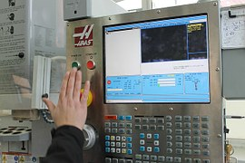

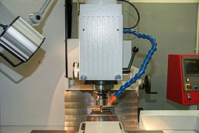

Sanasto:
to programme ohjelmoida
exactly tarkalleen
to carry out suorittaa
a process prosessi
according to jonkin mukaan
an instruction ohje
a programme ohjelma
finally lopulta
finished valmis
a piece of work työkappale

